Proposal for a Sports Tourism Marketing
Application Using Map-based Mobile Service

Jin-Ju Heo, Hye-bin Jeon, Sang-Hee Lee, Hye-jung Lee, Hye-Young Ko*

Dept. of Information and Contents Design Seoul Women’s University
Dept. of Contents Design Seoul Women’s University
DesignstudioA
Union of Absolute Valuable Company
Dept. of Digital Media Application Seoul Women’s University*

Seoul Women’s University
Seoul, Korea
wlswn1031@swu.ac.kr, wjs982247@gmail.com , dtong@hanmail.net, songddd@natrle.cin
kohy@swu.ac.kr*

Abstract

With the hosting of the Pyeongchang Winter Olympics ahead, tourism industry activation and economic growth through sport tourism marketing are expected. Accordingly, the present study is intended to propose a mobile app using map based services for marketing to sport tourists with the expansion of access to information and experience on winter sport facilities and regions.
Keywords-component; Pyeongchang Winter Olympics, Sport tourists, Sport tourism marketing,Map based services.

I. Introduction

With the hosting of the 2018 Pyeongchang Winter Olympics ahead, the tourism industry is expected to be activated because the 2018 Pyeongchang Winter Olympics is a global scale event with amusement. As can be seen from the case where the gross domestic product (hereinafter GDP) doubled between 1984 and 1988 when the Olympics were held, the positive effects of global sport events such as Olympics and the World Cup on tourism activation and economic growth are very large.[2] In particular, winter Olympics are quite meaningful for winter sport activation in Asia. In addition, the expansion of access to information and experience on winter sport facilities and regions based on winter Olympics will have large positive effects on the activation of winter sport tourism business.[3]
Therefore, strategic tourism marketing and services that can contribute to tourism and economic growth through the opportunity; the upcoming Pyeongchang Winter Olympics are necessary. In particular, the development of wireless Internet technology and the generalization of smart devices brought about many changes to tourism marketing and services too.

Fig. 1. Number of cases of use of public Wi-Fi in 2016[4]

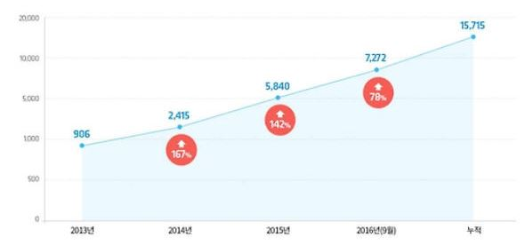
Following the development of information communication technologies and information technology (IT), electronic maps were developed into the form of the web geographic information system (hereinafter, GIS) and with the spreading of smart device supply, the area of map services using location based services (hereinafter, LBSs) has been spreading.[1]
LBSs are particularly frequently utilized in the field of tourism and are recognized to be important tourism services by tourists.
Geographic mobile application services using Web GIS and LBSs provide information on the geography of tourism destinations and experience activities in tourism destinations through concrete databases. This affects users’ decision making and may positively affect the formation of images of tourism destinations and cultural and economic effects of tourism destinations.[5,6,7]
Therefore, with the hosting of the Pyeongchang Winter Olympics ahead, the present study is intended to plan and propose a sport tourism mobile app utilizing map based services that can effectively achieve tourism marketing changing according to the development of information communication technologies. The characteristics of tourism regions that can be linked with the Pyeongchang Winter Olympics will be analyzed to determine the range of the study and winter sport tourists will be selected by type to set targets in two forms, main targets and sub targets and major functions will be defined through analyses of the characteristics of map API suitable for the targets thereby finally proposing the application.

Ⅱ. Contentst of research

1. Scope of the study and service target setting

The present study is regarding electronic maps for sport marketing intended to induce sport tourists’ interest and visits to the regions and the range is limited to electronic maps for sport marketing aimed to induce winter Olympics related tourists with four selected themes (food, rest, entertainment, and VR map experience).
Foreigners that visit winter sport regions for the first time are highly interested in the collection of regional information and have positive images about sport tourism. [5,6,8] In addition, they have the largest effect on economic growth based on GDP. Therefore, foreigners that visit South Korea to watch Pyeongchang Winter Olympics were set as primary targets and Pyeongchang Winter Olympics related organizations and neighboring merchants were set as secondary targets.

2. Major functions

1) Presentation of customized theme tourism maps using GPS technology
Based on the signals transmitted by the GPS satellite, this app can calculate 15m-30m locations to show location accuracy and to show the coordinates (latitude and longitude) of the object being tracked, this app may show theme tourism with map software such as Google Map and GPS Navigator.

2) Acquisition of revenues and public relations of
infrastructures around the stadium through Beacon
installation
Beacon can introduce information on user places and provide discount coupons through wireless communication devices that provide information and services for smart devices recognized in short distances based on Bluetooth thereby having the effect of marketing of the tourism of the surroundings of the stadium.

Fig. 2 Another service of location based technology[9]

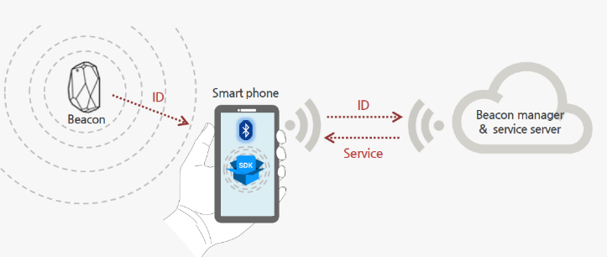

3. Structure map and theme contents

-Structure map proposal

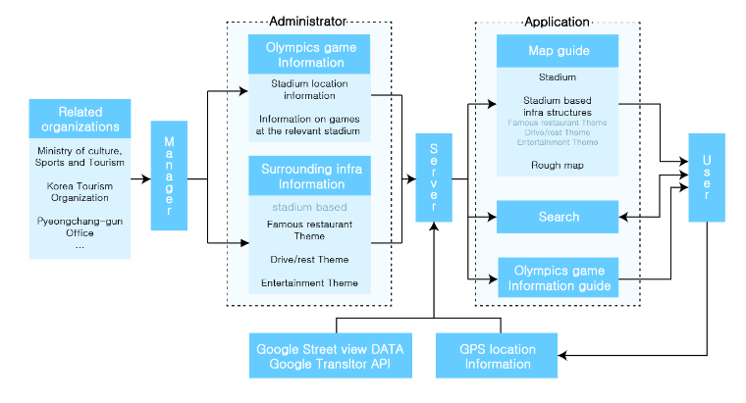

TABLE I
Theme Contents
Theme | Contents
Famous restaurant theme | Famous restaurants recommended by Korea Tourism Organization and Pyeongchang-gun office and those recommended by portal sites
Drive/rest theme | Courses to enjoy walks, nature, and drive together
Entertainment theme | Recommend attractions, entertainments, and accommodations and provide links to enable immediate connection for reservation
VR map experience | VR(in cases where there is no device, actual photos are experienced through panorama photos)

III. Conclusion

In the present study, a mobile application using map based services for sport tourism marketing that can enhance the positive effects of the Pyeongchang Winter Olympics on tourism activation and economic growth was proposed. The application is intended to provide services that improve convenience and satisfaction in terms of user experience by providing those pieces of information that are required by primary targets and secondary targets for each of four themes(famous restaurants, rest, entertainment, VR map experience). In addition, the provision of introduction of region information for major places and coupons to sport tourists when they utilize this application will lead to sales of regional merchants and will become a service that can contribute to the enhancement of economic effects through sport tourism marketing.

References

[1] Sang-Ah Park, “A Study on the Factors Affecting the Continuous Intention of Using Mobile Map : Centered on UI Comparison of Mobile Web and Mobile Application”, Yonsei University a Master’s thesis, 2012, pp.12-13.
- Reporter Eom Sang-Hyeon, “Governor Choi Mun-Su of Gangwon-do - Pyeongchang will open the times of national income U$30,000.”, Shindongah, November issue,2015.
- Young-Joo Lee, “Domestic winter sport tourism and 2018 PyeongChang Olympics”, KROEA TOURISM POLICY, 2014, pp.17-20.
- Source: 1,020 ‘public Wi-Fi’ stations that can be enjoyed free of charge were additionally prepared, Ministry of Science, ICT and Future Planning,2016
- Young-Kil Ko, Young-Dai, Kwak, “A Study on the Relationship between Information Searching and Personal Characteristics of Sports Tourists : Focused on a Sports Event of Yesan Chungnam” JOURNAL OF TOURISM&LEISURE RESEARCH 27(11), 2015.11, 253-268..
- Young-Kil Ko, Young-Dai, Kwak, “A Study on the Relationship between Information Searching and Personal Characteristics of Sports Tourists : Focused on a Sports Event of Yesan Chungnam” JOURNAL OF TOURISM&LEISURE RESEARCH 27(11), 2015.11, 253-268.
- Eun-ha Jeong,“A studyonvisitormotivationandsatisfactionof traditionalculturaldestination FocusingontheJeonjuHanokVillage”, JEONJU University a Master’s thesis, 2010
- Taks, M., Chalip, L. & B. C Green, S. Kesenne, S. Martyn, Factors Affecting Repeat Visitation and Flow-on Tourism as Sources of Event Strategy Sustainability., Journal of Sport & Tourism, 14, 2009, p121-142.
- nasmedia, Mobile Issue Report, ‘Another innovation of location based technology, Beacon’,2014

*This research was supported by the MISP(Ministry of Science, ICT & Future Planning), Korea, under the National Program for Excellence in SW) (R7116-16-1018) supervised by the IITP(Institute for Information & communications Technology Promotion)

